Adding and maintaining Call Numbers and Items
Call numbers and items are added and maintained in several places in Evergreen. Catalogers generally add new and maintain existing call numbers and items by accessing the Holdings editor from the Holdings View of a bibliographic record. Maintenance of copies can also be performed in item status (F5) and Item buckets; the holdings editor will open from any place where adding or editing call numbers/volumes and/or items is selected.

Navigating Holdings View
In holdings view, you will use the Actions menu to access the Holdings editor as well as to take direct actions on holdings.
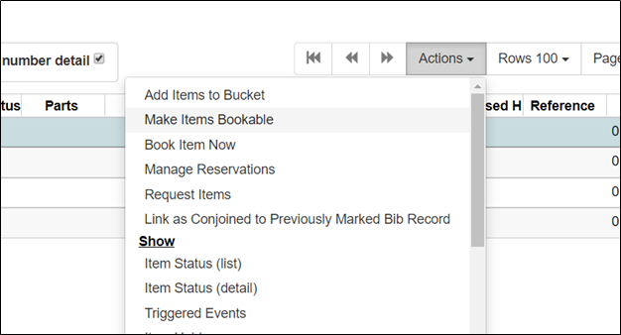
From the Actions menu, you can
Add items to Bucket
Make items bookable (not implemented by PINES)
Book item now (not implemented by PINES)
Manage reservations (not implemented by PINES)
Request items
Link as conjoined to previously marked Bib record (not implemented by PINES)
Show
- Item Status (list)
- Item Status (detail view)
- Item Holds
- Print Labels
Mark
- Item as Damaged
- Item as Discard/Weed see Discard/weed: Marking Items for Deaccessioning
- Item as Missing
- Library/Call Number as Transfer Destination Transferring volumes and items
Add
- Add Call Numbers
- Add Items
- Add Call Numbers and Items
- Add Item Alerts
Edit
- Edit Call numbers
- Edit Items
- Edit Call Numbers and Items
- Edit Replace Barcodes
- Edit Manage Item Alerts
Delete
- Delete Empty Call Numbers
- Delete Items
- Delete Call Numbers and Items
Transfer
- Call Numbers to Previously Marked Destination Transferring volumes and items
- Volumes to Previously Marked Destination (same as above)
- Items to Previously Marked Destination Transferring volumes and items

Personalizing Holdings View
Choose your library system from the dropdown menu at “Show holdings at or below”. Make sure the boxes to show empty call numbers, show empty libraries, show item detail, and show call number details are checked. You can uncheck these at any time, depending on what you are doing and what you need displayed.
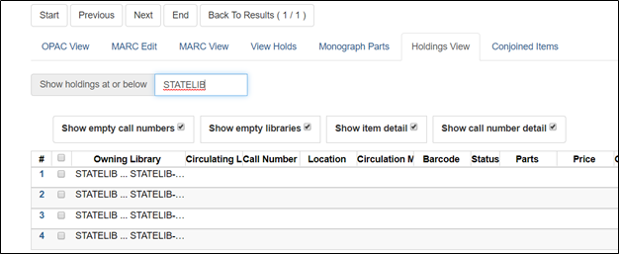
Your choices will stick until you change them.
Branches/Libraries are not always listed in Holdings View in alphabetical order. Pay attention to the order they are displayed in the Volume/Item editor to ensure you are associating the correct Item to each library.
From the column picker, select “Manage Columns”, to pick the attributes you wish to display and the order you want then displayed. You can resize columns from “Manage Column Widths.” Be sure to select “Save Columns” when you are done. You can change your column selections and order at any time. See Function Bar/Columns for further instructions.
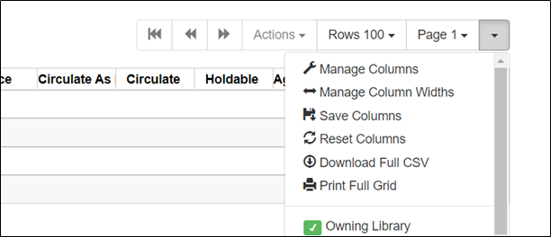
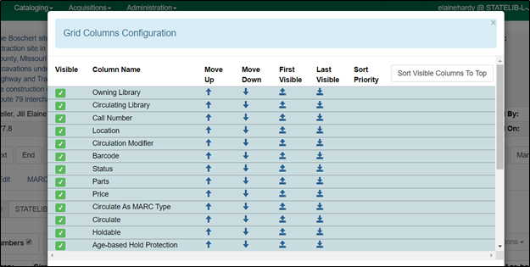
You can add or remove individual columns directly from the column picker.
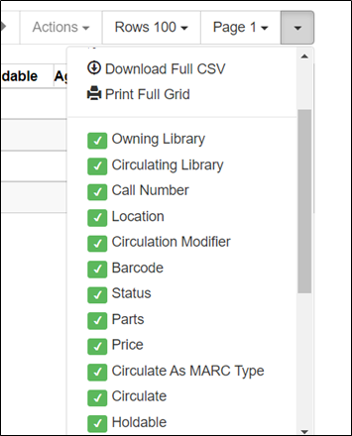
You can also select the number of rows you want to display on one page.
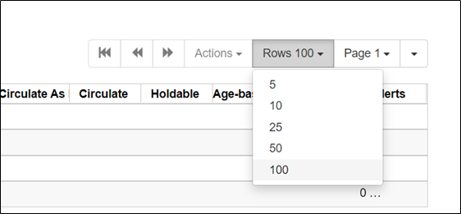
You can navigate through multiple pages using the arrows or the drop down menu to go to a specific page.

Personalizing the Holdings Editor
In the Holdings editor, you can add volumes and copies, add just copies, or edit copies and/or volumes. The Defaults tab lets you customize the attributes displayed in the editor.
You must access the holdings editor from holdings view of a bibliographic record. To set your defaults, choose a library and from the actions menu, select Add call numbers and items.
Setting default view for the Holdings editor
You can set a personalized view for the holdings editor that defines the attributes available for edit and how the editor displays. Unchecking an attribute removes it from the holdings editor display. Most attributes should be checked so that they are available to edit; however, some attributes, depending on local practice, can be unchecked and not displayed.
Click on the Defaults tab to deselect displayed attributes.
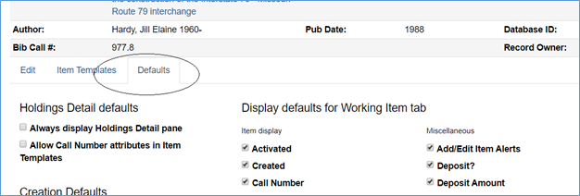
You can change your defaults at any point. You may need to re-display the browser page to see changes in the holdings editor.

Holdings Detail defaults
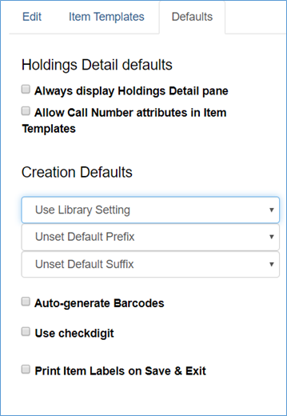
Always display Holdings Detail pane: Checking this will display the call number editor when you select Actions – Edit – Items.
Allow Call Number attributes in Item Templates: Checking this provides the ability to set some call number attributes in an item template. These include classification type (none, Generic, Dewey Decimal Classification (DDC), or Library of Congress Classification (LCC)) and any prefixes or subfixes you may use that would be compatible with the item template. Most PINES libraries have not implemented functionality for prefixes or subfixes separated from the basic call number.

Creation Defaults
Use Library Setting: defaults to the setting in Administration – Library settings. This first menu is to set your classification scheme. The default set for PINES under Administration – Library Settings – Cataloging – Default Classification Scheme is Dewey (Dewey Decimal Classification).
- Generic (no specified classification scheme)
- Dewey (DDC: (Dewey Decimal Classification))
- Library of Congress (LCC: Library of Congress Classification scheme)
Setting the call number classification to Generic or Dewey will influence how call numbers are sorted
Unset Default Prefix: For libraries with call number prefixes defined. Can choose a specific prefix to apply to all call numbers.
Unset Default Suffix: For libraries with call number suffixes defined. Can choose a specific suffix to apply to all call numbers.
Auto-generate Barcodes: PINES has not implemented, leave unchecked.
Use checkdigit: Checking allows for verification of the item barcode and should not allow an improperly formatted barcode to be entered. If your library does not use Codabar formatting for all barcodes, you should leave the box unchecked.
Print Item Labels on Save & Exit: If you wish to print spine or spine/pocket labels one at a time to accommodate editing for format and spacing, check the box. If you batch print spine or spine/pocket labels, leave unchecked.

Display defaults for Working Item tab
Unchecking attributes here removes them from display in the Holdings editor.
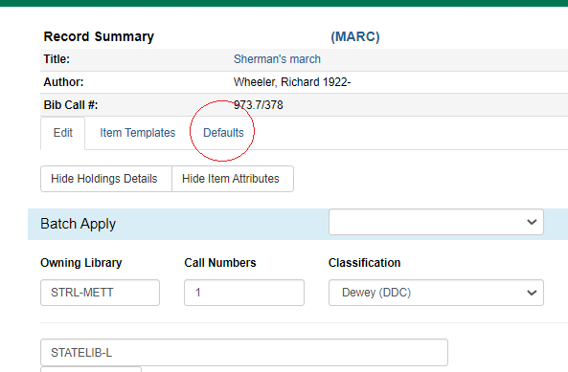
Item display:
- Activated: the date the Item was set to activate. Activation date differs from the create date. An item is set to active when the status is set to Available, Checked out, ILL, On holds shelf, On Reservation shelf, Reserves, or Reshelving. In PINES, the date an item is activated starts the age protection count.
- Created: the date the item was added to the PINES database.
- Call Number: the call number associated with the item.
Circulation
This section sets up how the attributes controlling circulation of an item display. PINES catalogers should leave the majority checked so that they display and are editable.
- Circulate?: Yes/true or no/false. Should be checked
- Circulation Library: Should be checked
- Circulation Modifier: Should be checked
- Circulate as Type: Checking is a local decision. This attribute should only be set if a library does not use circulation modifiers to define basic circulation policy. Best practice is to not use circulate as type with circulation modifiers since a Type that differs from the circulation modifier can change the circulation rules that govern the item.
- Loan Duration: Should be checked
- Fine Level: Should be checked
- Shelving Location: Should be checked
- Holdable?: Should be checked
- Age-based Hold Protection: Should be checked
Miscellaneous
- Add/Edit Item Alerts: May be unchecked if your library never uses item alerts.
- Deposit?: May be unchecked if your library does not have items in a deposit collection
- Deposit amount: May be unchecked if your library does not have items in a deposit collection
- OPAC Visible?: Should be checked
- Price: Should be checked
- Quality: PINES has not implemented. How an item's quality is defined effects holds. Can be unchecked.
- Reference?: Should be checked
- Acquisition Cost: Can be unchecked. This field is populated with the invoiced cost of the originating acquisition and will be empty if the originating acquisition is not connected to an invoice. Only valid for libraries using the acquisitions interface.
- Status: Should be checked.
- Add/Edit Item Notes: Should be checked, unless your library does not add Item notes.
- Item Notes are Public: Should be checked, unless your library only adds public notes.
Statistical Categories
- Default Filter Library: Can add the default library for display of statistical categories (statcats). Be aware that this will determine which statcats will be available if you have created different ones for different libraries.
- Edit Statistical Data: Should be checked, unless your library does not add statistical categories (statcats)
- Add/Edit Item Tags: PINES has not yet implemented, but may after we have evaluated and tested the functionality. Can be checked or unchecked.
Display defaults for Completed Items tab
This section determines which attributes display in the Completed Items Tab:
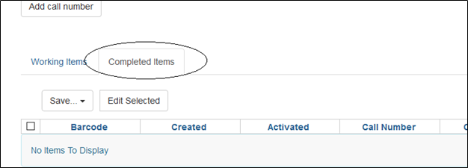
Choose those attributes you need to see on a regular basis in Completed Items.

Item templates tab
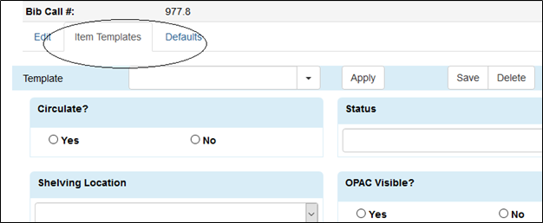
You can make changes to your templates or add new ones here. See Item templates for more information.
Once your defaults are set, there is no need to set them again unless you want to make changes. When ready, return to the Holdings Editor by clicking on the edit tab.

Adding New Holdings to a Bibliographic Record
You add new volumes and copies to bibliographic records, both when no call number exists on a record in the database and when adding additional items to an existing call number within Holdings view.
After you have identified a matching record, either in the PINES database or imported from OCLC’s WorldCat via the Z39.50 interface by following PINES matching procedures and policies, you are ready to add your library system holdings to the bibliographic record. See The Z39.50 interface, Bibliographic Matching Criteria (monographs only) : A Short Version
From a bibliographic record, select Holdings View.
From the list of libraries, choose the library or libraries for holdings:
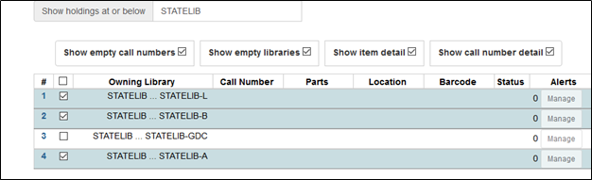
There are two ways to access the Holdings Editor from holdings view:
1) From the Actions menu, either from the drop down menu or right clicking, choose Add – Call numbers and Items:
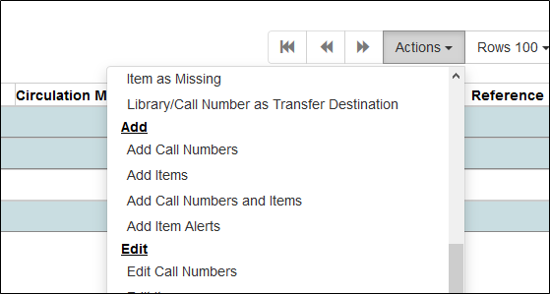
2) Click on the Add Holdings button, upper right of your screen just under the record summary.
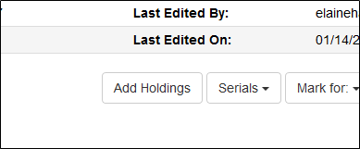
The Holdings editor will open.
You can add or remove libraries from the call number editor as needed after you have opened the holdings editor.
Depending on your task, you can Hide Holdings details (the call numbers and barcodes) or hide the Item Attributes:
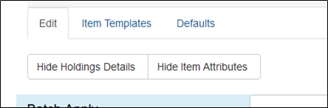
Batch Apply
If you are adding multiple volumes, either across multiple libraries, or for a multivolume set, you can Batch Apply the call number and any prefix or suffix. Click the Apply button when you are ready to add the call number to all volumes. Select the number of call numbers you need befor batch applying call numbers.
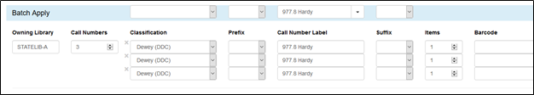
You can change the number of volumes for each library from the counter. Decreasing the number removes input wells, increasing it adds input wells.
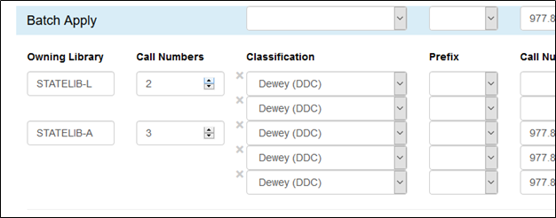
If you are adding multiple copies for call numbers, adjust the counter. As with call number entry, increasing or decreasing the counter changes the number of input wells. If your library uses them, you can add Item numbers.
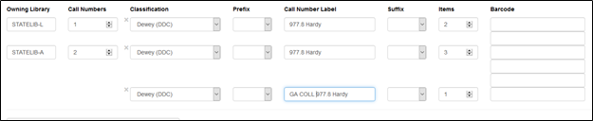
Scan in your barcodes.
Assign parts to print titles as needed (See Monographic and Serial Parts for more detailed instructions).
You must add call numbers and barcodes to all input wells to be able to save and add holdings.

Applying templates and editing attributes
Once you have added your call numbers and item barcodes, you edit attributes in the item editor. Here you can apply holdings templates and/or manually edit attributes. You can also add item notes and alert messages. See Adding and Managing Item Alert Messages for more detailed instructions.
When creating items, some values in the item editor are set to default but not always visibly. Green highlighting in the Holdings Editor indicates some default values or that an attribute has been edited, either manually or by application of a template.
For instructions on creating templates, see Item templates
Default values in the Item editor are:
- Circulate?: Yes
- Status: In process
- Circulation library: If adding volumes to one library, the circulation library will be set from the owning library, otherwise a drop down menu will display with the circulation libraries and the number of call numbers (volumes) for each. Leaving the circulation library unset when adding holdings to multiple libraries/branches allows Evergreen to set it from the owning library for each item. The circulation and owning library can be different. Setting to a different library than the owning library will set them as different.
- Shelving location (default is Stacks (PINES), if your template does not set the location, you will need to select it here)
- Status: In Process
- Reference?: No
- OPAC Visible?: Yes
- Holdable?: Yes
- Quality: Good (PINES has not implemented)
- Floating: <NONE> (Most libraries in PINES do not have floating collections and should leave this as the default)
- Fine level: Normal
- Duration: Normal

Editing attributes and applying holdings templates
- Pick the appropriate template from the drop down menu and click Apply.
- Make any other edits, such as price, as needed.
- You can either click on Save & Exit to save your work and close the holdings editor, redisplaying Holdings view with your new holdings, or click Store Selected, to verify your work and make additional edits as needed.
If the Item editor does not close and holdings view with your newly added call numbers and items does not open when you click Save & Edit, a critical attribute such as a barcode or call number is missing or your template failed. Check your work, make corrections, and try again. If the template failed, you may need to delete and recreate it.

Adding copies to existing call numbers
If you are adding additional items to an existing call number or numbers, select the call numbers. From the Actions menu, choose Add—Items. The holdings editor opens.
- Set the counter if you need to add more than one item.
- Scan barcodes into input well, setting item numbers if used and part labels if needed.
- Apply templates and make any additional edits to working items.
- Save & Exit
Any changes to the call number will edit the call number for all items attached to it.

Adding additional call numbers
You may need to add additional call numbers/volumes to a branch or library in cases where you might have a multivolume set, a serial, or are adding a volume to another shelving location such as reference. You may also need to add an empty volume as a transfer destination. See Transferring volumes and items for instructions
- Select the libraries/branches for the additional call numbers.
- From the Actions menu, select Add – Call Numbers and Items.
- Enter new call numbers and barcodes.
- Apply templates and make any additional edits to working items.
- Save & Exit

Editing call numbers and/or copies
You can make changes to just the call numbers, the call number and copies, or just the copies. You can also replace the barcode or manage item alerts from the edit section of the actions menu.
- Select the holding or holdings for editing
- From the Actions menu select the appropriate action:
  - Edit
    - Call numbers
    - Items
    - Call Numbers and Items
    - Replace Barcodes
  - Manage Item Alerts
- Make edits as needed.

Deleting call numbers and items
You can delete items and call numbers from an individual record in holdings view.
- Select the call numbers or items to be deleted
- From the Actions menu select the appropriate action:
  - Delete
    - Empty Call numbers
    - Items
    - Call Numbers and Items
If you delete the last item from a call number, the call number should also delete. Deleting the last item and call number attached to a bibliographic record should delete the record.

Using item status to maintain call numbers and copies
Generally, item status is used to maintain holdings across multiple bibliographic records. While you can add holdings here, use caution to make sure you have the correct record selected. Adding holdings is best done in individual records through holdings view to ensure you are adding the correct items to the correct records.
Take care in using item status for batch editing since redisplaying the tab or closing it can mean you lose your list of items. It is better to move items in item status to a bucket for batch editing.
See Cataloging Functions in Item Status for more informationitem_status

Using copy buckets to batch edit or delete call numbers and copies
In Item buckets, you can batch edit, transfer, or delete call numbers of copies across multiple bibliographic records.
Select the items for editing, transferring (see instructions for transferring), or deleting. It is better to work in groups of 100 or less to minimize processing time.
Select the action from the Actions menu.
If you are editing items, the Holdings editor will open. Make changes and then Save & Exit.

