Multi-part functionality in PINES

Monographic and Serial Parts in PINES
In order to allow holds on specific volumes in Evergreen, PINES has implemented Monographic and Serial parts functionality for print titles. This functionality links volumes in a multi-volume monograph or serial under a label assigned to each volume. These labels are distinguished from locally assigned call numbers in that they will use the same terminology and format for all PINES libraries while the locally assigned call number can still follow local rules and standards. Parts can be assigned at the time of cataloging or retrospectively.
Multipart functionality has not been implemented for sound recordings or visual materials in PINES. Do not assign labels to those formats.
Once parts are assigned to volumes, users will be able to place a hold on a specific volume. The OPAC holdings display will automatically add a column for the part designation.
In Holdings View and other lists, you may need to add Parts with the Column Picker (make sure to Save Grid Configuration). You will then be able to view the part label:
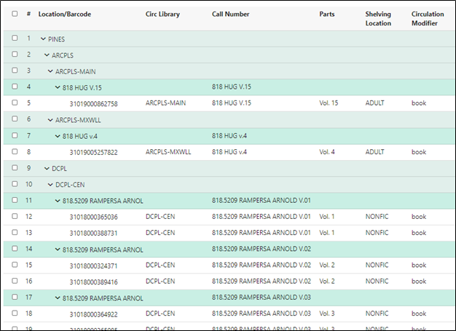
When placing a hold on a title with multiple parts, users will be prompted to choose a part:
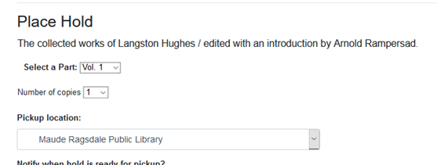
Once the hold is placed, the part label is displayed:
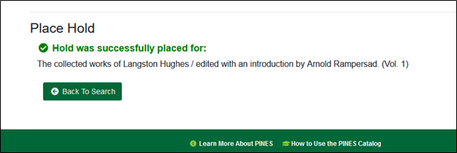
Within My Account, the part label also displays:
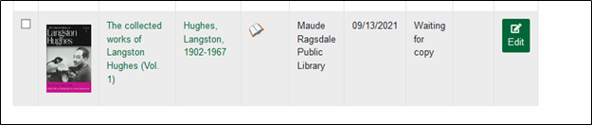

Placing holds when some parts do not have a label
If some volumes on a record do not have part labels, -Any Part- is displayed in the drop-down box when a user places a part hold:
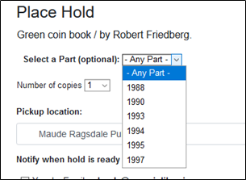
Selecting Any Parts places the hold only on those parts without a label rather than on any part attached to the record.
If all parts have assigned labels, only the labels display in the drop-down menu:
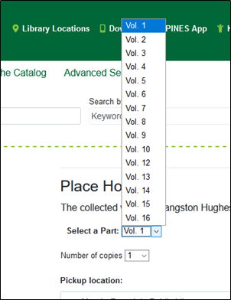
If the part is in a status that is not holdable, such as lost, the part will appear in the list but a hold cannot be placed.

Part labels for PINES Libraries : Format and Vocabulary
For consistency across all bibliographic records, PINES libraries will use a controlled vocabulary and format for multiple part labels. Please note that these designations may differ from local practice in the call number itself. Also note that the part label need not replace the volume designation in your local call number. For example, your local call number could be 016.92 CON v.45 but the part designation will be Vol. 45. Usage of a controlled vocabulary insures that the same label is assigned to all volumes on a bibliographic record. This enables holds to be placed across all volumes with the same label.
Assigning part labels does not change local formats for call number volume designations

Format
- Enter a space after the label and before the number designation: Vol. 45.
- Follow numbering conventions on your title. If Roman numerals (I, II, III) are used as the part/volume designation, use them in the part designation, if Arabic numerals (1, 2, 3), use them.
- If your item is a subdivision of another part designation, separate the string by commas and a space: Vol. 12, pt. 5.

Vocabulary
Use the following abbreviations only. If your title uses a term not included in this list, contact the PINES and Collaborative Projects Manager or the PINES Cataloging Specialist so that the new term can be added.
Vocabulary
Name | Abbreviation | Name | Abbreviation
Almanac | Almanac | Issue | Iss.
Appendix | App. | New Series | New Ser.
Addendum | Add. | Number | No.
Annual/Annual Collection | Annual | Parts | Pt.
Biography | Bio. | Primary Sources | Prim. Source
Book | Bk. | Publication | Pub.
Bulletin | Bull. | Schedule | Sched.
Chapter | Ch. | Season | Season
Division | Div. | Section | Sec.
Edition | Ed. | Series | Ser.
Episode | Ep. | Subsection | Subsec.
Fiscal Year | FY | Supplement | Suppl.
Index | Index | Volumes | Vol.

Dates
Dates should be entered as close to how they are indicated on the item as possible, yet still be within these standards.
- If the piece has January 2, ’15, enter as Jan. 2, 2015 or Jan. 2, 1915 etc., depending on which is the correct year.
- A range of dates should be entered as Jan. 2, 2015-Jan. 25, 2015 or Jan. 2, 2015-Feb. 12, 2015.
Years
- Enter as four digits: 2015, 1998, 1892, etc.
- Ranges of years are entered with full digits: 1991-1993, 1999-2010, etc.
- If years are in Roman numerals on the item, use Roman numerals in the parts designation.
Months
Use the following abbreviations:
Months
Name | Abbreviation
January | Jan.
February | Feb.
March | Mar.
April | Apr.
May | May
June | June
July | July
August | Aug.
September | Sept.
October | Oct.
November | Nov.
December | Dec.

Unavailable Label
In those instances where the volume designation cannot be determined because the item is in the database, the call number does not indicate the volume, and the item is not on the shelf because the item is lost, missing, long overdue, or similar status and cannot be deleted from the database, assign the label Unavailable. This will eliminate the -Any part– problem for holds.
Restrict the use of this label to those volumes where the part cannot be determined and are in a status that is not holdable. For reference copies, assign a label.

Managing Part Labels
Parts labels are managed under the Monograph Parts tab at the bibliographic record level. Here, they can be created, edited, merged, or deleted.

Creating parts
If no parts have been created for a title, or you have volumes that have not had labels created for them, you will need to create them following PINES guidelines. Click on the Monograph Parts tab
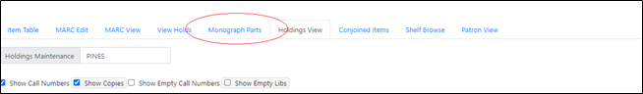
Create needed parts by clicking on New Monograph Part. A dialog box will open for you to provide the appropriate labels for the record:
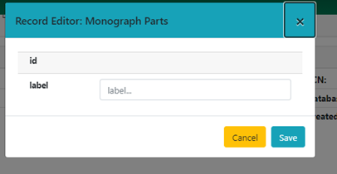
Enter the label designation and click Save.
If a label with the same name exists for the bibliographic record, the message Update Failed will briefly display to the lower right of the screen:
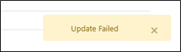
Once you are finished, the labels will be listed:
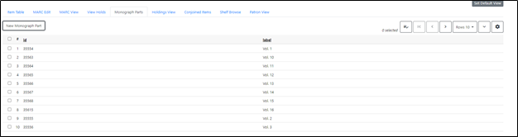
You may need to display more rows or page through mulitple pages to see all labels.
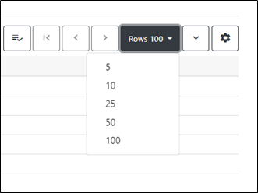

Assigning Parts at Cataloging
Once all of your parts are labeled, you can begin adding volumes to the record or assign labels to existing volumes.
In the Holdings Editor, in your normal process to add volumes, you will assign parts as you are adding volume and copies in the Volume and Copy Creator:
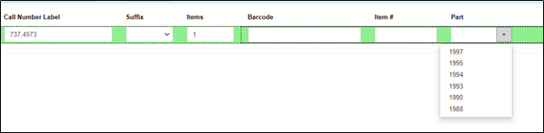
Proceed with creating your items and then Save & Exit.

Assigning Parts to Existing Volumes
To retrospectively assign part labels to existing volumes, first follow above directions to create labels for the parts, if necessary. Once the labels are created, go to the Holdings View tab and select the volumes for parts designation. From the Actions menu, Select Edit > Call numbers and items.
Select the appropriate label for your volume from the drop down menu:
Once you are done, click on Save & Exit.

Editing Parts
If you or someone else made an error in the label designation, you can edit it in Monograph Parts. Double click on the label to be edited. A dialog box will open. Make the needed changes and then Save. The change will propagate to all volumes assigned that label.

Merging Parts
If different part labels have been created for the same part, you can merge them so that all the volumes have the same label. In the Holdings View Tab, click on the labels to be merged, then click on the Merge Selected button. Select the correct label (prevailing item) and the merge will occur.
The change will propagate to all volumes assigned those labels.

Deleting labels
If incorrect labels exist with no attached volumes, you can delete them from the list. Choose the incorrect, empty, label and click on the Delete Selected button. The label deletes with no warning dialog.

