Record buckets
In the Evergreen staff client, record buckets are virtual containers that hold title records for batch processing. Record buckets allow for merging duplicate records and deleting several records at one time. Catalogers primarily use record buckets to merge duplicate bibliographic records. While they can be used to delete records, since Evergreen automatically deletes a bibliographic record when the last item and call number is removed from holdings, deleting records in batch from a record bucket is rarely necessary. Record buckets can also be used to transfer title holds and to export the bibliographic record. PINES catalogers rarely need to do either.

Record Bucket Basics
The record bucket interface is accessed from the Cataloging menu- Record Buckets:
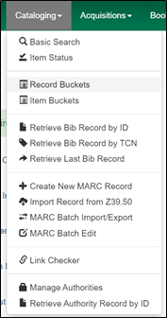
Or from the Home page:
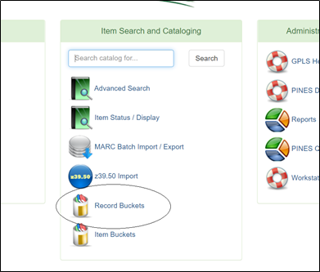

Bucket view
The Record Bucket interface opens in Bucket View.
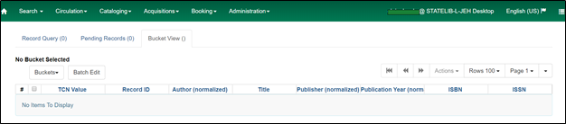
As with all other list interfaces in Evergreen, you can configure the arrangement and composition of the lists in Bucket View, Pending Records, and Record Query for your needs using the column picker. See Function Bar/Columns
There is currently a bug that negatively impacts Record Query functionality if Record ID is deselected as a column. Leave Record ID in the bucket list to enable all query functionality.
In Bucket View, you can create, edit, or delete buckets. You can also access a shared bucket or your existing buckets:


