Invoices
You can create invoices from purchase orders, individual line items, as well as creating blank invoices that charges can be added to. You can also link entire purchase orders and particular line items to existing invoices. Funds switch from encumbered to spent when the paid column of an invoice is filled in and the invoice is saved.
If desired, you can create an invoice for items before you receive them. You are able to re-open closed invoices to make adjustments as well as print out all invoices.
Flexible workflows are available with electronic invoicing to accommodate vendors’ invoicing practices. Vendors can send EDI invoices that automatically link to purchase orders or that you can link as needed.

Invoice Interface
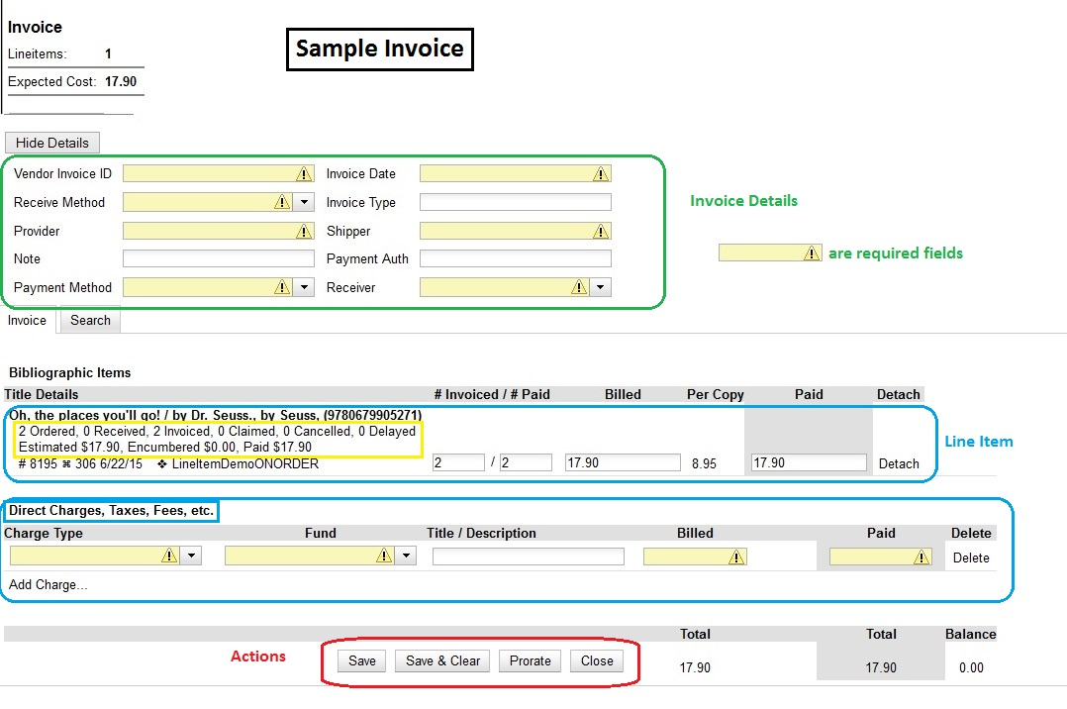

Invoice Details
The Invoice Details section is hidden when the invoice appears on the screen. Click on Show Details to reveal the section. The required fields must be completed for every invoice created. EDI invoices automatically populate some fields as noted.
The Invoice Details fields are:
- Vendor Invoice ID - Required
This number may be listed on the paper invoice and is part of the electronic invoice sent by your provider.
- Receive Method - Required
Two choices are paper or EDI; EDI is automatically filled on receipt of the electronic invoice.
- Provider and Shipper - Required
These fields will auto-complete based on the purchase order. Your shipper is usually the same as your provider.
- Note
This is an optional field that can be used as needed.EDI invoices generate a note in this field.
- Payment Method - Required
Available payment methods display in a drop down menu. PINES defaults are cash, check, credit card, debit card, electronic funds transfer, MasterCard, PayPal and Visa. Additional payment methods can be requested.
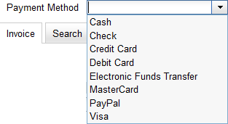
- Invoice Date - Required
By default this is the date the invoice is created on. The date can be changed by clicking the field and selecting a new date using the calendar widget. EDI invoices automatically fill in this field.
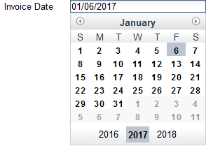
- Invoice Type
This field is used if your library distinguishes between types of invoices.
- Payment Authorization
This field is used if your library requires authorization for payments.
- Receiver - Required
This field defaults to the location at which your workstation is registered. If necessary, you can change the receiver using the drop down menu.
The Invoice Details automatically hides once completed. The Invoice Details can be shown at any time by clicking Show Details.

Invoice Line Items
Line Items appear without their attributes but with a summary of copies ordered, received, invoiced, claimed and canceled. Also available are amounts estimated, encumbered and paid along with the line item ID and links to selection list and purchase order.

Invoice Charges
Additional charges can be added to any invoice. Most often charges are for processing, cataloging or shipping. Some charges are proratable. Vendors can populate this line with EDI invoices also.

Invoice Actions
There are 4 options for saving an invoice;
- Save to save changes and remain in the current screen;
- Save & Clear to save changes made to the current invoice and clear to continue invoicing with a new invoice;
- Prorate to save the current invoice and prorate any additional charges across funds used to pay the invoice; and
- Close to save changes, expend funds and complete the invoice.
Upon invoice completion, all 4 buttons are replaced with a Reopen button which enables you to reopen and change closed invoices.

View an Invoice
You can view an invoice in one of three ways:
- View Invoices Through a Search
- View Invoices on a Purchase Order
- View Invoices Attached to a Line Item

View Invoices Through a Search
The default invoice search allows you to quickly generate a list of open invoices. This search can also easily be modified to search for invoices using other parameters.
To access the searching interface, select Acquisitions→Open Invoices.
The Acquisitions Search screen opens with fields set to search for open invoices. To search for closed or completed invoices, place a check in the Complete check box.
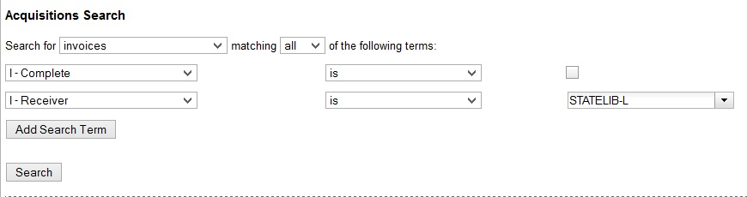
By default the search interface is set to search for open invoices created by the agency your workstation is logged into. You may need to change the receiver from the default to your ordering agency, unless a default for Receiver has been set in Library Settings Editor.

View Invoices on a Purchase Order
Open a purchase order.
Click View Invoices. The number in parentheses indicates the number of invoices attached to the purchase order.
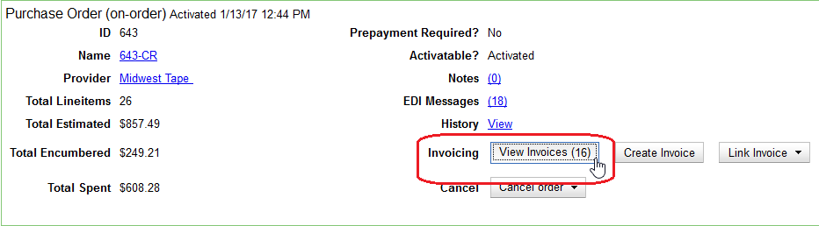
Select the invoice you would like to display from the grid that appears. The invoice will appear in the current tab.

View Invoices Attached to a Line Item
Open a purchase order.
Click View Invoice(s) on the Line Item.
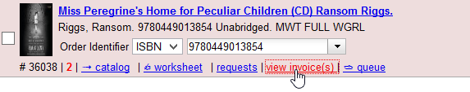
Select the invoice you would like to display from the grid that appears.
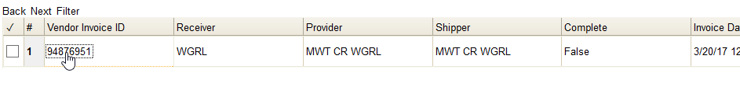
The invoice will appear in the current tab.
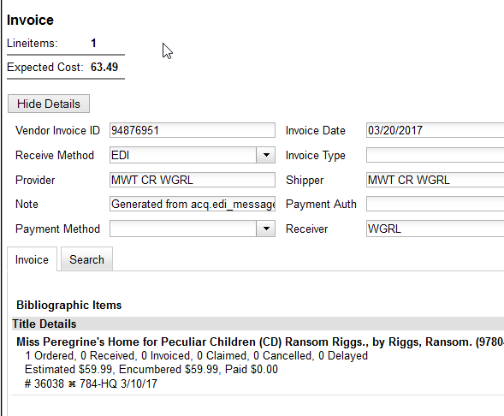

Populating Invoices
Line items can be added to invoices in three ways:
- Link an Entire Purchase Order to an Existing Invoice
- Link Multiple Line Items to an Existing Invoice
- Search for Line Items From an Invoice

Link an Entire Purchase Order to an Existing Invoice
You can use the Link Invoice button to link all the line items on a purchase order to an existing invoice.
For example, an invoice is received for a shipment with items on purchase order #1 and purchase order #2. When the invoice arrives, purchase order #1 is retrieved, and the invoice is created. Rather than recreate the invoice for purchase order #2 you simply link the purchase order to the invoice.
Open a purchase order.
Click Link Invoice.
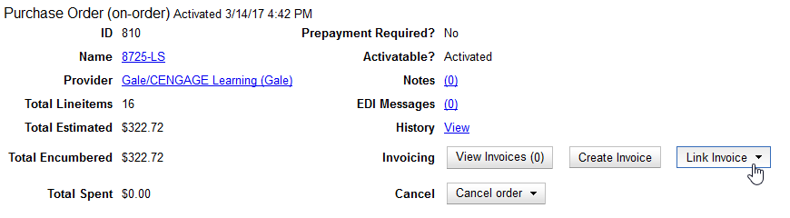
In the drop down that appears, enter the invoice number of the invoice you want to link to the purchase order.
Enter the code for the provider. This field will auto-complete.
Click Link.
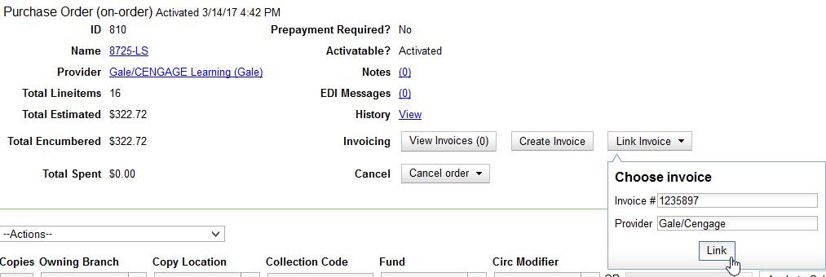
The invoice will open in the same tab and all the line items on the purchase order will be added to the invoice.

Link Multiple Line Items to an Existing Invoice
Use the Link to Invoice for Selected Line Items from the Actions menu option to link multiple line items to an invoice that already exists in Evergreen.
For example, an invoice may be made up of items from multiple purchase orders. In this circumstance, you can create an invoice for the selected line items from your first purchase order and then link the line items from other purchase orders onto your invoice.
Open a purchase order.
Check the boxes beside the line items you would like to link to your invoice.
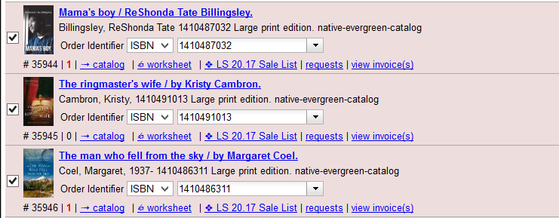
Using the main Actions menu, select Actions→Link Selected Line Items to Invoice.
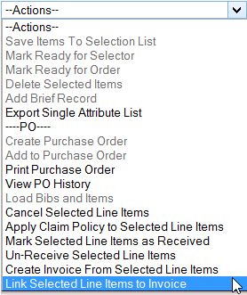
In the pop-up box that appears, enter the invoice number of the invoice you would like to link the line item to. Enter the code for the provider. This field will auto-complete. Click Link.
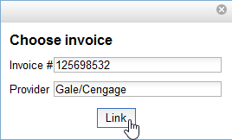
The Invoice # and Provider fields are sticky. The information entered in those fields will persist as you move between purchase orders until you change the information.
The invoice will open in the same tab and the line items will be added to the invoice.

Search for Line Items From an Invoice
You can use the Search tab to search for and add line items to an invoice from within the invoice.
Open an invoice or Create an Invoice.
Click the Search tab.
Select your search criteria from the drop down menu. See Searching for Line Items for general searching tips.
The Limit to Invoiceable Items check box is checked by default.
Invoiceable items are those that are on order, have not been canceled, and have not yet been invoiced.
The Sort by title check box is optional. By default, results are listed by line number. This check box sorts the results by ascending title.
Click Search or press Enter.
Search will start a new search while Enter will build on your current search. For example, choose LIA-ISBN as your search field, type in the ISBN of your first book and press Enter. The line item will appear in the results list. Then, type your next ISBN into the search box and press Enter. Both line items will now appear in the results list. Continue building your list.
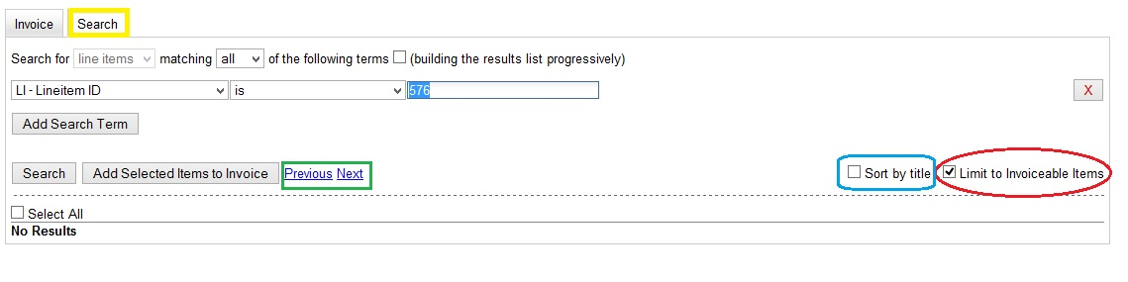
Use the Next and Back links to navigate through the results.
Select the line items you would like to add to the invoice and click Add Selected Items to Invoice.
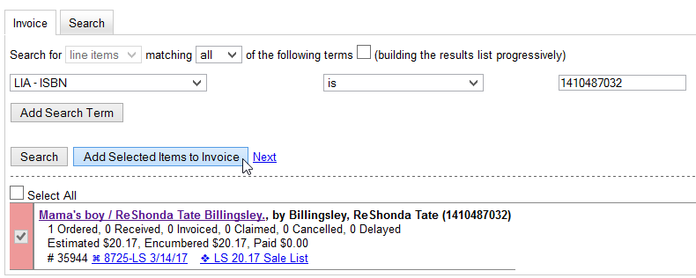
The selected line items are highlighted, and the invoice summary at the top of the screen updates.
Click the Invoice tab to see the updated invoice.
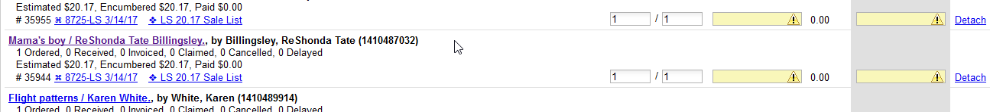

Blanket Order Invoices and Receiving
Blanket Orders allow staff to invoice an encumbered amount multiple times, paying off the charge over a period of time. Invoices for blanket orders are created from the purchase order interface of the particular blanket PO for which you wish to create an invoice. Alternatively, if the purchase order needs to be finalized without creating a final invoice, the Finalize Blanket Order button on the purchase order interface.
Blanket Order items do not need to be Marked as Received as these charges are not linked to line items.

Create Blanket Invoice
Locate and open the blanket purchase order.
From the blanket purchase order’s interface, click on Create Invoice.
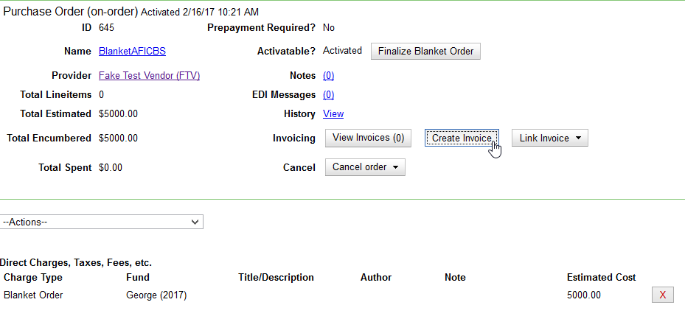
Fill in the top section of the invoice. See Invoice Details for guidelines.
Enter the amount billed into the Billed field. The Paid field will auto-fill to match and the fund will have auto-populated with the Fund used on the Purchase Order.
Enter an optional Title/Description.
Click Save to save the invoice.
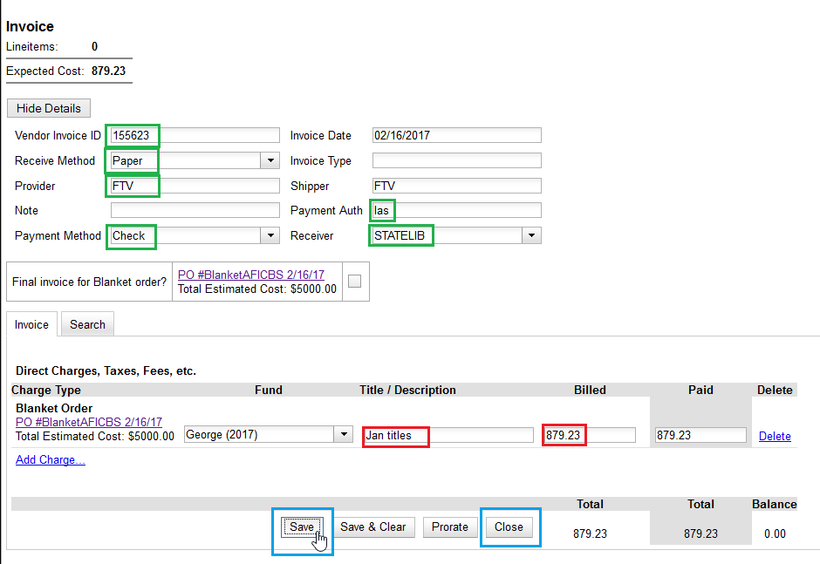
Click Close to close the invoice. Funds will move from encumbered to spent.
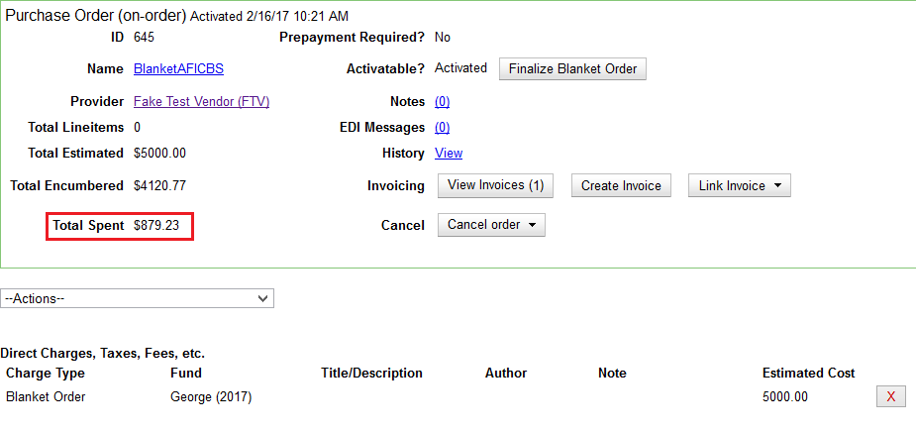

Finalize Blanket Order Invoice
When the final shipment arrives locate and open the blanket purchase order.
From the purchase order click on Create Invoice.
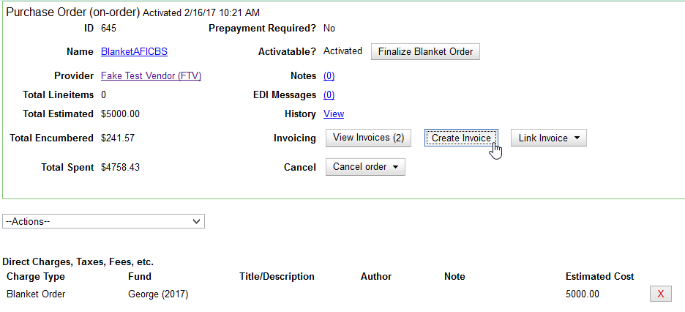
Fill in the top section of the invoice. See Invoice Details for guidelines.
Select the Final Invoice for Blanket Order checkbox to mark the Blanket Purchase Order as Received and drop any remaining encumbrances to $0.00.
Enter the amount billed into the Billed field. The Paid field will auto-populate to match and the fund will have auto-populated with the Fund used on the Purchase Order.
Click Save.
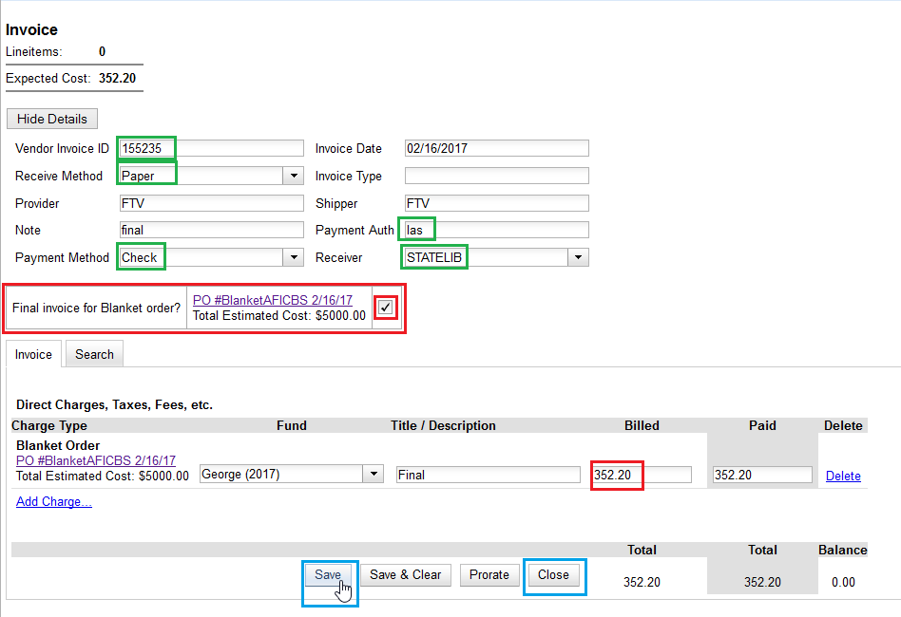
Click Close to close the invoice, change the status of the purchase order to received, and return any remaining encumbrances to the designated fund so that Total Encumbered now equals $0.00.
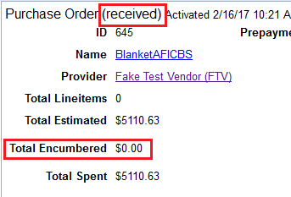

Finalize Blanket Order from Purchase Order
If a blanket purchase order needs to be finalized without creating a final invoice, use the Finalize Blanket Order option on the purchase order interface.
Locate and open the blanket purchase order.
In the blanket purchase order click on the Finalize Blanket Order button on the Activatable? line.
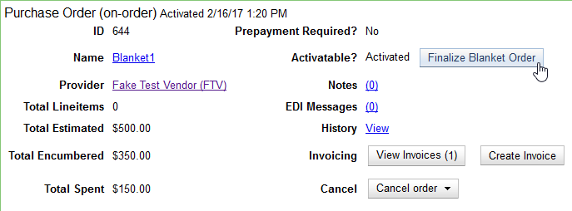
A pop-up box will appear asking to confirm the finalization of the purchase order. Click OK to confirm the action.
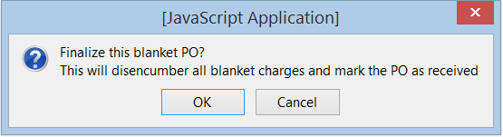
The purchase order status will change to Received and the encumbered amount will change to $0.00, showing that all the remaining funds are returned to the designated fund.
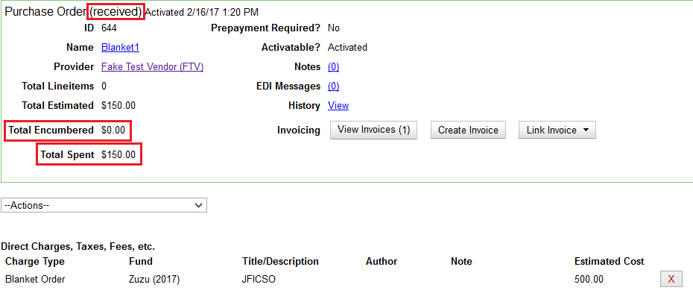

Direct Charges
You can add additional charges to any invoice. Possible charges include shipping fees and processing charges as well as charges for items that are purchased without a purchase order. See Invoice Item Type for a list of the charge types.
Some charge types are proratable. This means when Prorate is clicked, the system divides the amount being charged proportionally among the funds in use on the invoice based on how much is being spent out of each fund.

Add Additional Copies to an Invoice
In the event that you receive and are invoiced for more copies than originally ordered, the additional copies can be easily added to the invoice.
Open an invoice.
Update the number of copies in both # Invoiced and # Paid to reflect the number of copies you actually have.
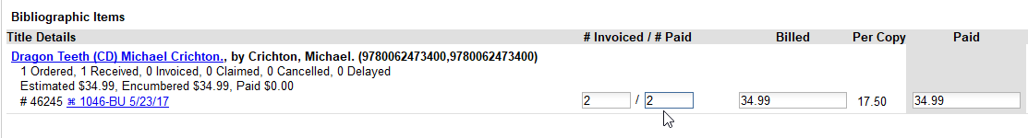
The Extra Items pop-up will appear to confirm the number of copies you are adding. Select a fund from the drop down menu to apply to the new copies. Click Add New Items.
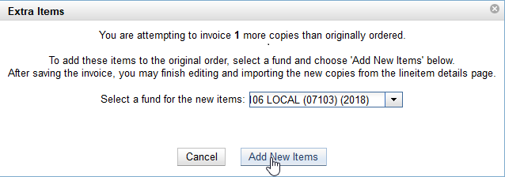
Click Save to allow the changes to take effect.
The Title Details for the line item will update to reflect the additional copies. The additional copies are automatically received in the system. Proceed with paying the invoice.

Electronic Invoicing
If you are using EDI to transmit orders, then Evergreen can receive electronic invoices from providers for those orders.
Electronic invoices save having to create invoices and link the line items or populate invoices and fill in the billed and paid information. Once an electronic invoice is linked to its purchase order(s), it is paid and saved just as you would any invoice.
Electronic invoices can viewed just like other invoices through a search, through a purchase order’s View Invoices button, or through Line Item’s invoice link. See the section on View an Invoice.
Electronic invoicing also provides other viewing and access options.
- Access invoices from a provider record.
- Invoices automatically link to purchase orders.

Access Invoices From A Provider Record
You can view an invoice from the Provider Record under the Invoices tab. Click on Admin → Acquisitions Administration → Providers to view a list of providers for your ordering agency.
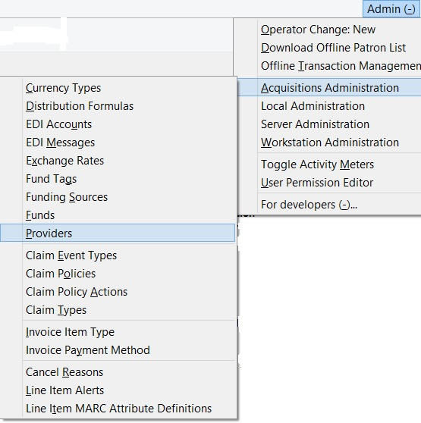
Choose the appropriate provider from the list.
On the bottom half of the provider screen, choose the Invoices tab.
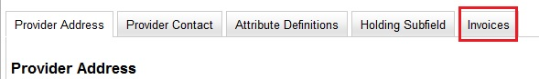
A list of invoices appears. Click on the Vendor invoice ID to view all invoices from the vendor.

Re-open an Invoice
Completed invoices can be reopened at any time by users with appropriate permissions.
Bring up the completed invoice you wish to reopen.
At the bottom of the invoice, click Reopen.
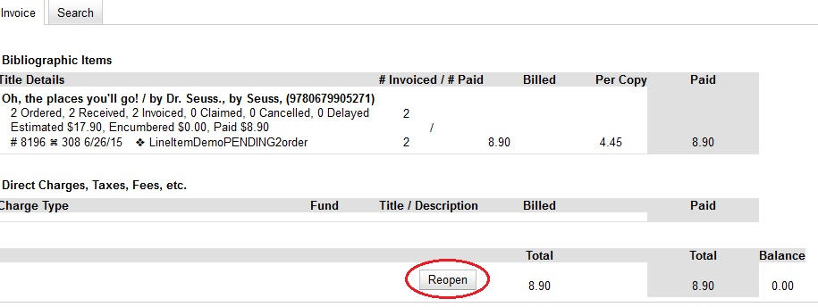
The invoice is now open and can be edited.

