Year End Closeout

What is Year End?
Year End closeout is the method that Acquisitions uses to close out one fiscal year and begin another.

What happens in year end?
- For funds marked propagate, a new fund with the same parameters (code, name, etc) is created in the new fiscal year
- For funds marked rollover, with the intent to–
  - Rollover encumbrances only - Any unspent money in the fund is NOT rolled into the next year’s fund; it is deallocated back to its originating funding source. Existing fund debits in the fund are transferred to the next year’s fund, and the funds used in affected line item details will be updated to the new year's fund
  - Rollover encumbrances and money - Any unspent money in the fund is rolled into the next year’s fund, existing fund debits are transferred into the next year’s fund, and the funds used in affected line item details will be updated to the new year's fund
- For funds not marked rollover, any unspent money in the fund is deallocated back to its originating funding source
- Old year funds are marked as inactive so new debits can’t be charged to it

How to prepare for year end
Preparing for year-end mainly involves cleaning up your acquisitions activities over the past year and tying up any loose ends. This is mainly done through running a series of reports to give you a snapshot on the status of your acquisitions.

Acquisitions freeze
In terms of acquisitions, “freeze” generally refers to making purchases. So this would mean halting purchasing for the length of the freeze, not stopping marking items received or closing invoices.
Whether or not to establish an acquisitions freeze is a local decision. There are several reasons why you may want to institute an acquisitions freeze, whether it’s for a month or a week.
An acquisitions freeze of at least the day of the closeout is REQUIRED. Freezing longer than that is a local decision.
Why might you want to establish a longer acquisitions freeze?
- Allows on-order items to arrive, be received and invoiced
- The more items that are received and invoiced before running your reports, the shorter your reports (and the information you’ll need to look through) will be

Canceling backorders
Whether or not to cancel backorders is a local decision, but that decision must consider the way that funds are set up.
If you have purchase orders in your current fiscal year where you would like the backorders to carry into the next fiscal year, the following settings are required:
- Funds must be marked marked “rollover”
- Must follow closeout instructions for “Rollover encumbrances only” or “Rollover encumbrances and money”

Reports
There are several reports to run, and there is a somewhat logical order to run the reports in. You may wish to follow the workflow proscribed here. All reports are located in Reports→Shared Templates→PINESacqadmin→Year End Reports.
It is best to run these reports only a few days to a week prior to closeout, so that as many items can be resolved as possible prior to running the reports.
1. Report: “List of funds with parameters”
This report is to aggregate all the parameters of each of your funds for you to confirm that they have the appropriate settings before closeout
Done | Action
 | Confirm that all the funds you wish to be propagated in the new year have Propagate=True
 | Confirm that only the funds you wish money and/or encumbrances to rollover have Rollover=True
 | Any fund marked Rollover=True must also be marked Propagate=True
2. Report: “Line items that have not been received”
The goal after cleaning up with this report is that all line items will be either received or cancelled. If encumbrances are carried forward, “on-order” or “backordered” are also acceptable.
Done | Action
 | Verify using packing slips if items were physically received
 | If they were, mark items received in Acquisitions
 | If not received, check if items were backordered/cancelled by the vendor. If so, mark backordered/cancelled in Acquisitions
 | If choosing to cancel backorders, you may wish to cancel with vendors at this point and mark items as Cancelled in Acquisitions
 | If not cancelling backorders, confirm that these items are billed out to funds marked Rollover=True
3. Report: “Purchase orders with pending or on-order status”
Done | Action
 | If there are any purchase orders that are in pending status that you wish to order, they should be activated
 | If there are POs that you did not want to order (errors, POs with all line items deleted, etc), you may want to change the PO names to designate that they are not real orders (e.g. DELETE-Mayordererror)
 | Most of the on-order POs should have been cleaned up by the previous report (Line items not received), so you may want to investigate any remaining POs with a status of “on-order”
4. Report: “List of invoices that are not closed”
Done | Action
 | Confirm if invoices have already been sent to Accounting for payment
 | If so, mark invoices as closed
 | If invoices have not been sent, close and send for payment
There should be no open invoices by the time closeout is performed.
5. Report: “Fund summary”
If you have funds that rollover money and/or encumbrances, you may wish to run this report immediately prior to doing your dry run closeout. That way when you view the dry run of the new created funds you can spot-check that the numbers are correct, and once you do the final closeout you can compare against the money and/or encumbrances that were moved between fund years.

Dry Run
The Acquisitions module provides you a method to do a “pretend” closeout to double-check that your funds, money and/or encumbrances will be carried over correctly and successfully before doing it for real. This is called doing the “dry run.”
Doing the dry run, you will use the same settings as when you do the closeout, but VERY IMPORTANTLY, you will check the “dry run” box.
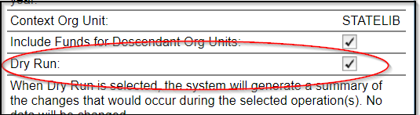
Instructions for doing the dry run are included as part of the steps for performing closeout, and depend on whether you are rolling over or not:
- No rollover
- Rollover encumbrances only
- Rollover encumbrances and unspent money

Year End Closeout
After you have done your prep work of running reports, cleaning up your data and doing a dry run, you should be ready to complete your year end closeout.
Each of the sections below includes instructions for running a dry run before completing the official closeout. This is highly recommended.

No rollover
1. Using your Fund report, ensure that all of your funds are marked Rollover=FALSE.
2. Open Administration→Acquisitions Administration→Funds.
3. Ensure your Context Org Unit is set to your system level.
4. At the top right, you will see a button marked Fund Propagation & Rollover. When clicked, this will expand the closeout menu.
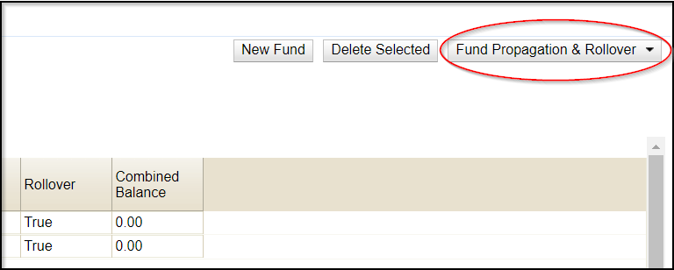
5. To perform the dry run first, the options below should be checked:
- Perform Fiscal Year Close-out Operation
- Include Funds for Descendant Org Units
- Context Org Unit should be your system (not a branch)
- Dry Run
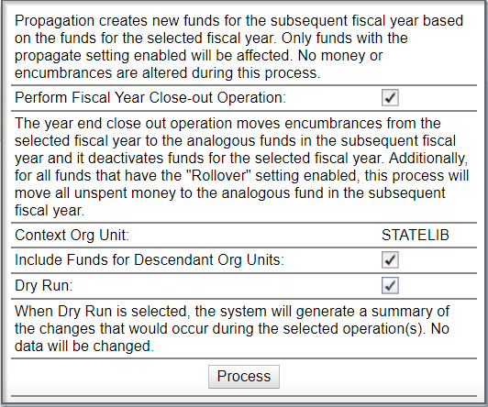
6. Click Process.
7. The screen will refresh to give you a snapshot of what your funds will look like when created in the new fiscal year. Ensure that the area at the top confirms that no money will be rolled into the new year.
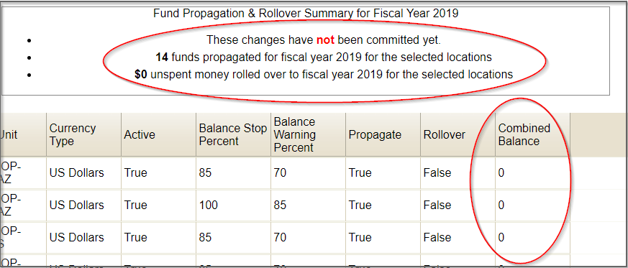
8. If everything is correct, reopen the Funds screen via Administration→Acquisitions Administration→Funds.
8. Repeat steps 3 and 4.
9. To do the real closeout, these options should be checked on the closeout pop-up:
- Perform Fiscal Year Close-out Operation
- Context Org Unit should be your system (not a branch)
- Include Funds for Descendant Org Units
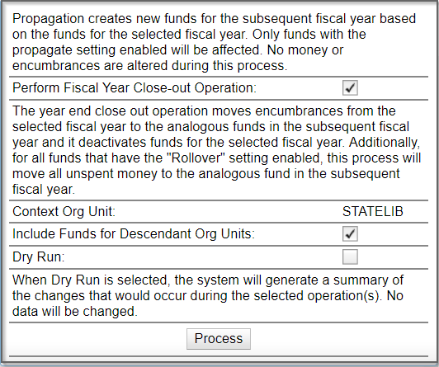
10. Click Process.

Rollover encumbrances only
<fc #ff0000>This will affect ALL FUNDS marked as Rollover=True</fc>
1. Using your Fund Parameters report, confirm that all funds that you want encumbrances to roll over are set as Rollover=True.
2. Open Administration→Local Administration→Library Settings Editor.
3. Filter the list to your system level. Ensure that “Allow funds to be rolled over without bringing the money along” is set to TRUE.
4. Open Administration→Acquisitions Administration→Funds.
5. Ensure your Context Org Unit is set to your system level.
6. At the top right, you will see a button marked Fund Propagation & Rollover. When clicked, this will expand the closeout menu.
7. To perform the dry run first, the options below should be checked:
- Perform Fiscal Year Close-out Operation
- Limit Fiscal Year Close-out Operation to Encumbrances
- Include Funds for Descendant Org Units
- Dry Run
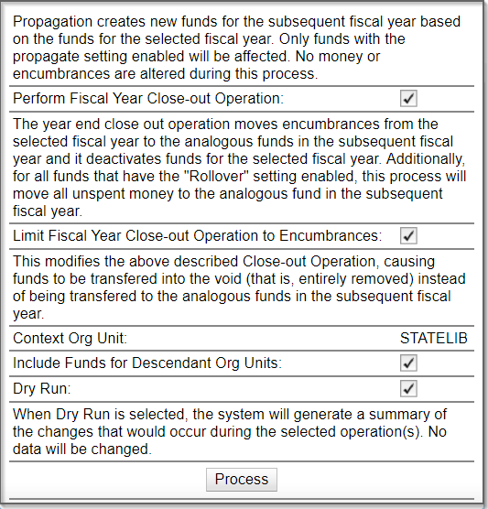
8. Click Process.
9. The screen will refresh to give you a snapshot of what your funds will look like when created in the new fiscal year. Ensure that the area at the top confirms that no money will be rolled into the new year.
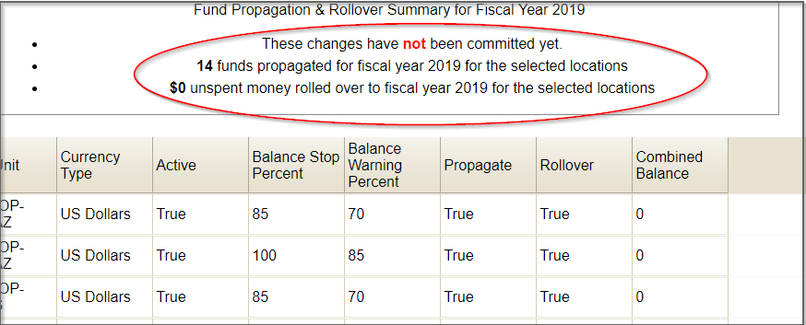
Notice that the balance for all funds is $0.00. It does not show negative numbers to indicate the encumbrances.
10. If everything is correct, reopen the Funds screen via Administration→Acquisitions Administration→Funds.
11. Repeat steps 5 and 6.
12. To do the real closeout, these options should be checked on the closeout pop-up:
- Perform Fiscal Year Close-out Operation
- Limit Fiscal Year Close-out Operation to Encumbrances
- Context Org Unit should be your system (not a branch)
- Include Funds for Descendant Org Units
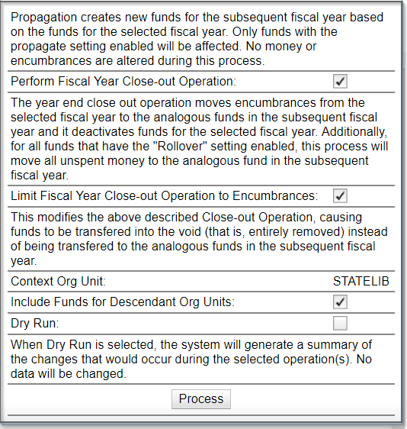
13. Click Process.

Rollover encumbrances and unspent money
<fc #ff0000>This will affect ALL FUNDS marked Rollover=TRUE</fc>
1. Using your Fund Parameters report, ensure that all funds to be rolled over are marked Rollover=True.
2. Open Administration→Local Administration→Library Settings Editor.
3. Filter the list to your system level. Ensure that “Allow funds to be rolled over without bringing the money along” is set to FALSE.
4. Open Administration→Acquisitions Administration→Funds.
5. Ensure your Context Org Unit is set to your system level.
6. At the top right, you will see a button marked Fund Propagation & Rollover. When clicked, this will expand the closeout menu.
7. To perform the dry run first, the options below should be checked:
- Perform Fiscal Year Close-out Operation
- Context Org Unit: (Should be your system level)
- Include Funds for Descendent Units
- Dry Run
8. Click Process.
9. The screen will refresh to give you a snapshot of what your funds will look like when created in the new fiscal year. Ensure that the area at the top confirms that the correct amount of money will be rolled into the new year.
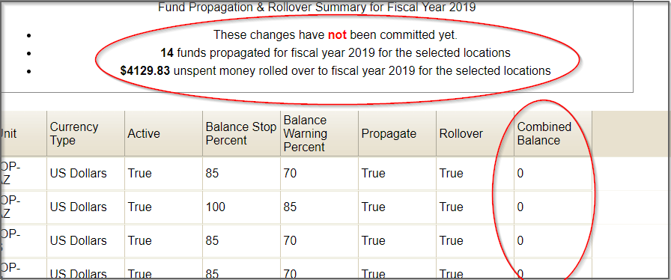
Notice that the balance for all funds is $0.00. It does not show balances per fund for the money to be rolled over.
10. If everything is correct, reopen the funds screen via Administration→Acquisitions Administration→Funds.
11. Repeat steps 5 and 6.
12. To do the real closeout, these options should be checked on the closeout pop-up:
- Perform Fiscal Year Close-out Operation
- Context Org Unit: (Should be your system level)
- Include Funds for Descendent Units
13. Click Process.

Starting the new fiscal year
Once you have done your closeout, you are officially into your new fiscal year in Evergreen. There are only a few more tasks to finish up closeout and beginning your new year.
- Run the “Fund Summary” report using the new fund year to confirm that all money and/or encumbrances were accurately rolled over (compare against last year’s report that you ran immediately prior to closeout)
- Run the report “Line items using outgoing fund year” to find any line items on selection lists or pending purchase orders using funds for the previous fund year. These need to be manually changed to the corresponding fund in the new year.
- Create new funding sources for the new fiscal year
- Apply credit to funding sources
- Allocate to funds
- Lift the Acquisitions freeze

