Address Alerts
You may alert your circulation staff when patrons register new cards with specified street addresses. For example, the address of a large apartment building might be entered in order to alert staff to be sure to include the unit number.
How will this affect the patrons?
This feature only serves to provide pertinent information to your library system's circulation staff during the registration process. An alert will not prevent the new patron account from being registered and the information will not be permanently associated with the patron account.
Who will see the alert?
The alert will only appear to library staff working in a specified library system or branch during the patron registration process or when changing a patron's address. For example, if an address is flagged for ARL, any ARL branch staff member registering a new patron with that address will see the alert. However, if a patron living within ARL's coverage area registers for their card at a non-ARL library, the library staff there will not see the alert.
Will libraries be required to use this feature?
No, it will be up to each library system to decide whether or not to use this feature. It will also be up to each library system to determine what types of addresses should be flagged, how the alert messages should be worded, and which staff members should be granted the ability to add addresses to the address alert list.
Who can add an address to the alert list?
All designated Local Administrators have the permissions to add and edit addresses that will generate alerts. The Local Administrators also have the ability to grant permissions to other staff members as needed. The pertinent permission is ADMIN_ADDRESS_ALERT. (Please note that each library system that chooses to use this feature is responsible for maintaining its own list of addresses.)
What will the library staff see when they enter a flagged address?
Library staff will see a dashed red line and an alert message off to the side after entering a flagged address and tabbing or clicking out of the address fields. It may take a moment for the alert to appear.
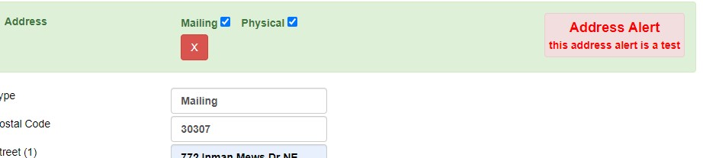Alert message example
How to add an address to the alert list:
- Log into the Evergreen Staff Client using a Local Administrator account or another account that has been granted the proper permission.
- Click on Administration > Local Administration > Address Alerts.
- Click “New Address Alert.”
- A form will open with the following fields to fill out:
  - Owner (Choose your library system or branch. This controls which staff members will see the alert.)
  - Active (Check)
  - Match All Fields (Check)
  - Alert Message (Enter the message you wish to display to staff members.)
  - Street (1) (Consider using wildcards - see below.)
  - Street (2) (Consider using wildcards - see below.)
  - City
  - County
  - State (Consider using wildcards - see below.)
  - Country
  - Postal Code (Consider using wildcards - see below.)
  - Billing Address (Check)
  - Mailing Address (Check)
How to use wildcards:
You may use a dot-asterisk (.*) as a wildcard to accommodate slight variations in addresses. For example “123 W.* Smith St.*” will generate an alert whether the patron's address is entered as “123 West Smith Street” or as “123 West Smith Str.” or as “123 W. Smith St.” You may add wildcards in the Postal Code field to adjust for the various four-number codes that are added. For example, “30236.*” will accommodate “30236” and “30236-1234.” If you use “G.*” it will accommodate both “GA” and “Georgia.”
How to edit or delete an address on the alert list:
Double-click on any address in the list in order to edit it. If you wish to delete an address, select the checkbox next to the address and then click the “Delete Selected” button.

