Overlaying Bibliographic Records
An essential database clean-up function is overlaying existing records in PINES with current records from OCLC. While the most likely reason to overlay is to improve a poor quality record, you will also want to overlay an existing record that does not have an OCLC based TCN or that may have improved subject or name headings in its current form in OCLC. Overlaying also is performed in conjunction with merging duplicate records (Merging Bibliographic Records).
When you have identified a PINES record needing a current OCLC record, you will need to mark it for overlay. In the Mark for menu at the upper right hand of the record display, choose Overlay Target:
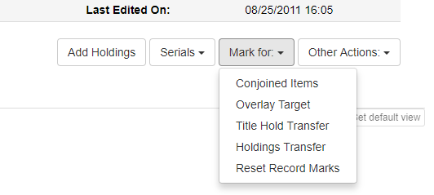
The Mark for menu will update with the Database ID of the marked record.
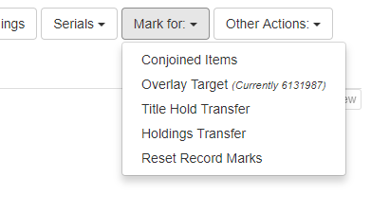
Reset Record Marks clears all marked records.
Leave the record open and open a new tab to search OCLC in the Z39.50 gateway. Identify a matching OCLC record to overlay.
While the dialog noting the marked record uses the label TCN, it is not the title control number for the PINES database. It is the PINES Database ID.
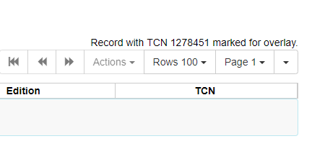
From the list of results, highlight the matching record (even if only one record is in the list) to activate the Overlay button.
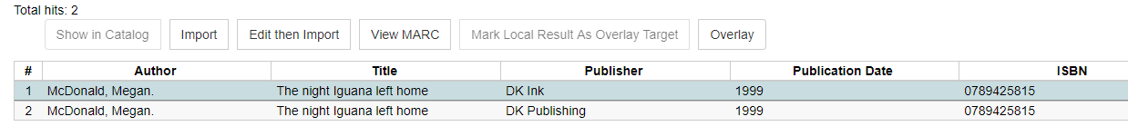
A screen will open with both records side by side. Compare and make sure you have chosen the correct record. If not, close the screen and search again.
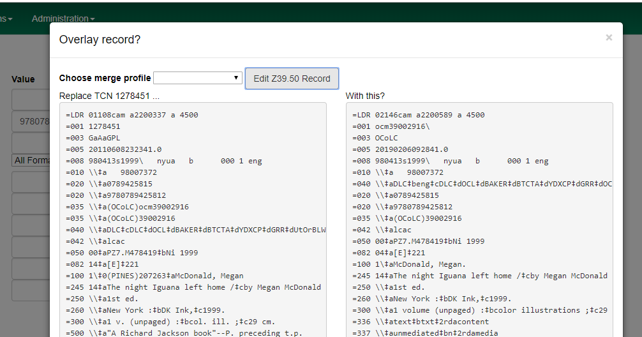
If you have the incorrect record from the PINES database marked for overlay, close the overlay screen and the Z39.50 tab. Locate the correct record in PINES and then mark it for overlay. Reopen the Z39.50 tab. (if you do not close or redisplay the Z39.50 tab, the marked record will not update).
You can also make edits to the incoming OCLC record before you merge. Click on the Edit Z39.50 Record button to open the MARC editor. Once you have completed your changes, click on the save button to be returned to Overlay Record.
Note: Best practice is to edit the record in the OCLC Connexion client before bringing it into the PINES database. However, there are cases where you can edit at import or overlay. If you are adding a heading for Georgia authors, for example, you should add them here and not to the OCLC master record. Also, if you are not trained to edit in OCLC, you can make corrections to the record here. Ask the PINES Cataloging Coordinator or the PINES and Collaborative Projects Manager if you have any questions.
If both records are correct, click on the overlay button at the bottom of the screen:
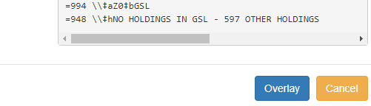
Currently there is no notification if the overlay is successful or fails. If it does fail you must check for a record with the OCLC master record TCN in the PINES database. Remember that the TCN will have a prefix of on, ocn, or ocm in PINES.
Go to the tab for the record to be overlaid to check if it was successfully overlaid. Redisplay the page and verify within the record summary for Last Edited By and Last Edited On. If Last Edited By is not you and the date not the current date, then the overlay failed because another record with that TCN is in the PINES database. Search and take appropriate actions such as merging and overlaying.
While the marked record will be cleared at overlay, if you leave the Z39.50 interface open in a tab, subsequently marking another record for overlay will not update the open tab. Best practice is to close the tab after overlay or to immediately refresh the Z39.50 tab before you search OCLC. Refreshing after you search will clear any search.

