"My Account" Access
PINES users have access to selected areas of their personal patron record, including checkouts, fines/bills, holds placed, and other information through the My Account section of the OPAC (https://gapines.org/login).
Once logged in to their account, patrons will be directed to the “My Account Summary” screen. From here, patrons can do the following:
- View current charges and payment history. If a library takes online payments, patrons can pay for current charges from their account.
- View and delete messages.
- View current items checked out and checkout history (if they have turned on this setting; see “Checkout History” below).
- View and edit hold requests.
- Edit personal and account information (username and password), notification preferences, and search and history settings.
- Manage item lists.
Note that staff users can update their account information, preferences, and password through the OPAC just as patrons can.

Checkout History
Patrons have the option to automatically store their own checkout history and access it through their My Account login. This option is turned off by default, but patrons may turn it on using the following steps:
- Go to My Account.
- Click Personal Information.
- Click Search & History.
- Check the box next to Keep history of checked out items?
- Click Save.
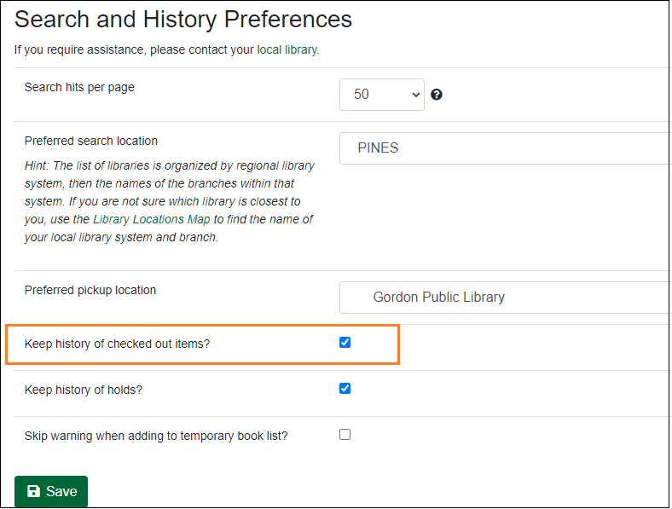
Library staff cannot see the patron’s checkout history through the staff client [2015.12].

Account Password
Access to the personal patron record is available only through the PINES library card number and password or personal identification number (PIN) for each user, as all library records are confidential in nature. The assigned PIN should be provided to the user at the time of library card registration. Patrons have the ability to change their own PIN/password after accessing the record with the correct library card number and provided PIN/password. Library staff should encourage patrons to log in to the OPAC and change the assigned password to a password of their own choosing as soon as possible for security and privacy purposes [2014.12]. Some patrons may need staff assistance in remembering the current PIN/password to access their patron record.
If the patron needs to reset their password, there are a few options:
- Patrons may reset their password in person at any PINES participating library with proper identification.
- Patrons may request a password reset by phone by calling a PINES library. The patron must be able to provide the library staff person with the barcode number, full name, date of birth, and either address or phone number.
- Patrons may reset their passwords from the “My Account” page if they have a valid email address on file via the “Forgot your password?” functionality [2006.05].
The user may also use the “My Account” options to select a text username to use in lieu of the library barcode for OPAC access.

Resources
For a list of frequently asked questions from patrons, see the FAQ.
For a video tutorial on using the OPAC, see Using the PINES Catalog (for Library Staff)
The following are infographics that guide the patron through updating their account information and preferences, and renewing items:
- How to Update Account Preferences
- How to Renew Items

