In-House Use
To record in-house use, go to Circulation > Record-In House Use, or press F6.
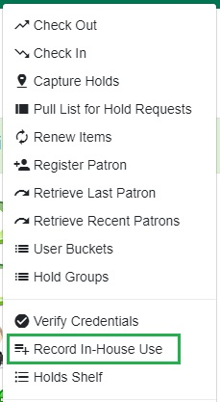
To record in-house use for cataloged items:
- Enter the number of uses.
- Scan or type the barcode.
- Click Submit.
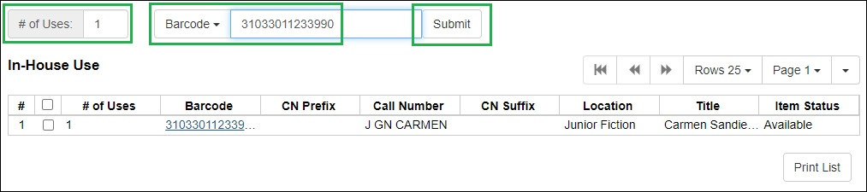
To record in-house use for non-cataloged items:
- Enter the number of uses.
- Click the barcode dropdown to select the item type.
- Click Submit.
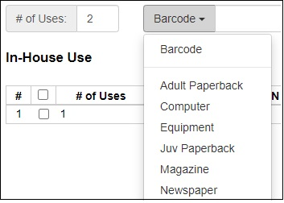
Print List allows you to print the list of items recorded. You can also run Quick Reports or Executive Snapshots to retrieve in-house circulation data.

