Browser Tools
The Evergreen web client is optimized to work with the current versions of Chrome and Firefox. Other browsers are not officially supported. Your browser must be set to allow popups, cookies, and JavaScript.
Although we do not endorse one browser over the other, the Hatch local storage / printing program only works with Chrome at this time. If you wish to have better control over printing or if you wish to save local configuration settings (column configurations, registered workstations, custom print templates, etc.) without worrying about them being cleared out if you clear your cookies, then you will need to use Hatch with Chrome.

Allowing Popups
Your browser must allow popups from gapines.org. You should see a small icon or message when a popup is triggered, but if you do not, you may follow these steps to ensure that popups are allowed.

Allow Popups In Chrome
- Click on the menu icon (three vertical dots in the upper-right corner).
- Select Settings.
- Scroll to the bottom and click Advanced.
- Under “Privacy and Security” click “Content settings.”
- Click on “Popups and Redirects.”
- Click the Add button next to Allow.
- Type in https://gapines.org and click Add.

Allow Popups In Firefox
- Click the menu button (three horizontal lines in the upper-right corner).
- Select Options.
- Click on Privacy & Security.
- Scroll down until you see “Block pop-up windows” in the Permissions section.
- Click the Exceptions button.
- Type in http://gapines.org and click Allow.
- Click Save Changes.

Standard Browser Functions
Since the client is web-based, you can use common keyboard shortcuts and functions such as selections, copy & paste, and right-clicks to access menus.
- 15+ Keyboard Shortcuts
- 47 Keyboard Shortcuts That Work in All Web Browsers
- Firefox and Other Browser Keyboard Shortcuts (Comparison Table)

Bookmarks and Profiles
The web client allows you to bookmark the pages that you use the most, and to use your browser's existing functionality to build your own custom toolbars and even to use browser profiles for different activities.

Firefox Bookmark Extensions
You can use Firefox's built-in Bookmarks Toolbar to create a custom toolbar, or you can install free extensions to customize your bookmark toolbars even further (Menu > Add-Ons > Extensions > Search). There are many extensions available, but a few that you may find useful are:
- Multirow Bookmarks Toolbar: Makes your built-in Bookmarks Toolbar wrap to multiple rows.
- More Bookmarks Toolbar: Adds a second bookmarks toolbar.
- Bookmarks Favicon Images: Allows you to customize the icons for your bookmarks.

Chrome Bookmark Extensions
You can use Chrome's built-in Bookmarks Bar, or you can install free extensions to customize your bookmark toolbars even further (Menu > More Tools > Extensions > Get more extensions). There are many extensions available, but a few that you may find useful are:
- Bookmark Manager (by Google): More sophisticated bookmark tools including search capabilities and folder suggestions.
- EverSync: Another way to sync, backup, and restore your bookmarks.
- Switchmark: Switch between multiple bookmark bars.

Firefox Sync
Firefox Sync is a free tool that allows you to synchronize your bookmarks, add-ons, and browsing history across multiple computers and mobile devices. This is useful for staff who work in multiple locations.
- See: Set up Firefox Sync

Chrome People
Chrome People allows you to synchronize your bookmarks, add-ons, and browsing history across multiple computers and mobile devices. This is useful for staff who work in multiple locations. You can also set up Chrome profiles to separate work activities from personal activities or to separate different types of work activities, or for multiple staff who need to use the same computer.
- See: Chrome profiles / people

Export Bookmarks from Firefox
- Click Bookmarks > Show All Bookmarks.
- Click the Import and Backup dropdown menu.
- Select Export Bookmarks to HTML.

Export Bookmarks from Chrome
- In Chrome, click on the menu icon (3 vertical dots at upper-right corner of browser).
- Click on Bookmarks > Bookmarks Manager.
- Click the Organize dropdown menu.
- Select Export bookmarks to HTML file.

Set Up Default Email
If you want to be able to click on a linked email address and have it launch a new email window in your preferred email system (ie, Gmail, Microsoft Outlook, etc.), you may need to configure your browser so that it understands what type of email window to open.

Default Email in Firefox
- Click on Menu (three lines in upper-right).
- Select Options.
- Scroll down to the Applications section.
- Click the dropdown next to the “mailto” option to set your preferences.
- (There is no Save button - it will save as soon as you make your selection.)
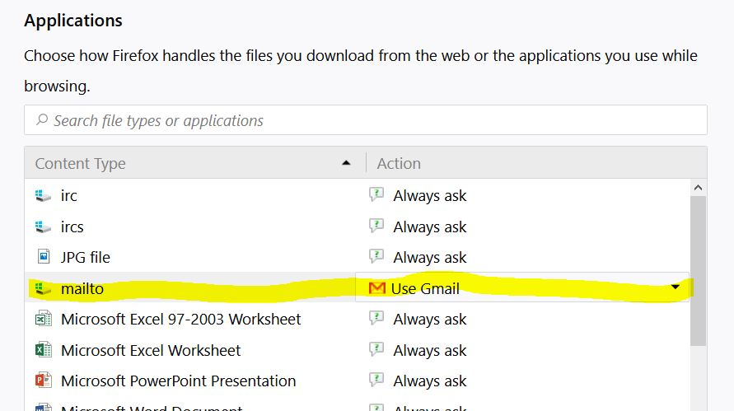

Default Email in Chrome
By default, Chrome should launch whatever your Windows default email system is (for example, if Windows is set to use a program such as Microsoft Outlook or Thunderbird as your email program). If you want to change Chrome to launch Gmail instead, follow these instructions:
- Open Gmail in Chrome and click the Protocol Handler icon (two overlapping diamonds) in your browser's address bar. 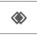
- When prompted to “Allow Gmail to open all email links?”, select “Use Gmail,” and click “Done.”
If Chrome is set to Gmail to default, but you need to change it back to your Windows default, you'll need to clear out your Chrome settings:
- Click the menu icon (three vertical dots in upper-right).
- Click Settings.
- Scroll down to the bottom and click Advanced.
- Scroll down to Privacy and Security.
- Click on Content Settings.
- Scroll down and click on Handlers.
- Delete Gmail as the mailto handler.

