PINES Executive Snapshots
PINES Executive Snapshots are a set of reports that are pre-run on a monthly basis for each branch and system. You can access the data for the most recent month, or for any month going back to January 2017.
- Open up the PINES Quick Reports interface (https://gapines.org/report-creator).
- Click on Executive Snapshot.
- Select the branch(es) or system(s) you are interested in viewing reports for. You may also select “PINES” to see data for the consortium.
- Select the month you wish to view data for. (Note, you cannot choose the current month.)
- Check the checkboxes next to each type of information you would like to see.
- Click Run Report.
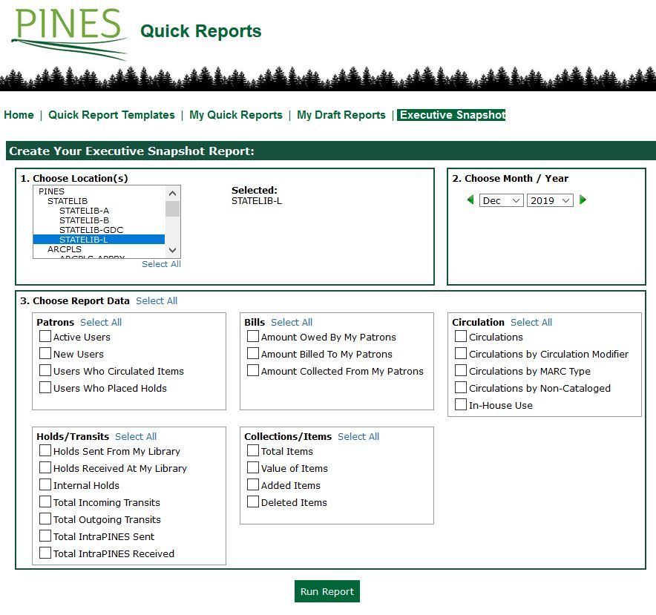
A page will appear with links to view the reports for each of the branches/systems you selected in either HTML (on screen) or Excel format.
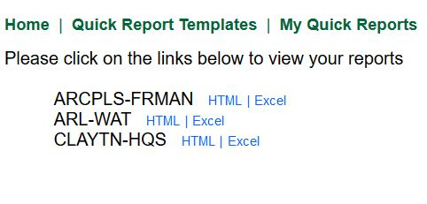
The resulting report provides the pieces of information that you requested as well as change comparison data from the previous month and the previous year.
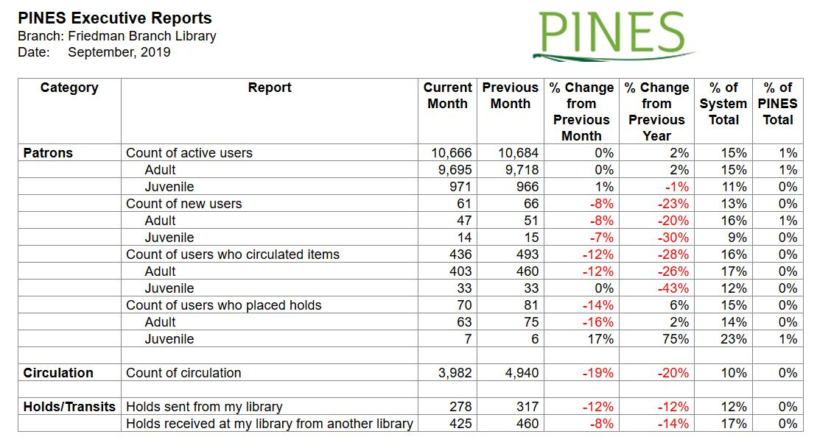

Descriptions of Data
Patrons
Report Data | Description
Active Users | Count of active users at the specified point in time (broken out into adult and juvenile).
New Users | Count of user accounts created within the specified month (broken out into adult and juvenile).
Users Who Circulated Items | Count of users who checked out items within the specificed month (broken out into adult and juvenile).
Users Who Placed Holds | Count of users who placed holds within the specified month (broken out into adult and juvenile).
Bills
Report Data | Description
Amount Owed By My Patrons | Total amount owed by patrons at the specified point in time.
Amount Billed To My Patrons | Total amount billed to patrons within the specified month.
Amount Collected From My Patrons | Total amount paid by patrons within the specified month.
Circulation
Report Data | Description
Circulations | Count of all circulations within the specified month (includes non-cat and in-house use).
Circulations by Circulation Modifier | Count of circulations broken out by circulation modifier within the specified month.
Circulations by MARC Type | Count of circulations broken out by MARC type within the specified month.
Circulations by Non-Cataloged | Count of circulations of non-cataloged items within the specified month.
In-House Use | Count of in-house use circulations within the specified month.
Holds/Transits
Report Data | Description
Holds Sent From My Library | Count of items sent by library to other libraries to fulfill holds within the specified month.
Holds Received At My Library | Count of items received by library from other libraries to fulfill holds within the specified month.
Internal Holds | Count of holds fulfilled within the specified month where the item owning library and patron home library are the same.
Total Incoming Transits | Count of transits received by library within the specified month.
Total Outgoing Transits | Count of transits sent by library within the specified month.
Total IntraPINES Sent | Count of items sent by system to other systems to fulfill holds within the specified month.
Total IntraPINES Received | Count of items received by system from other systems to fulfill holds within the specified month.
Collections/Items
Report Data | Description
Total Items | Count of total items owned at the specified point in time.
Value of Items | Total price of all items owned at the specified point in time.
Added Items | Count of items added within the specified month.
Deleted Items | Count of items deleted within the specified month.

