Reports Notes and Tips
The following are general notes and tips that may be helpful when using the Reports interface in the staff client:
- When looking at a subfolder or list of report templates in the Reports interface, make sure to change “Limit output to” to “All” or else you won’t see all of the templates.
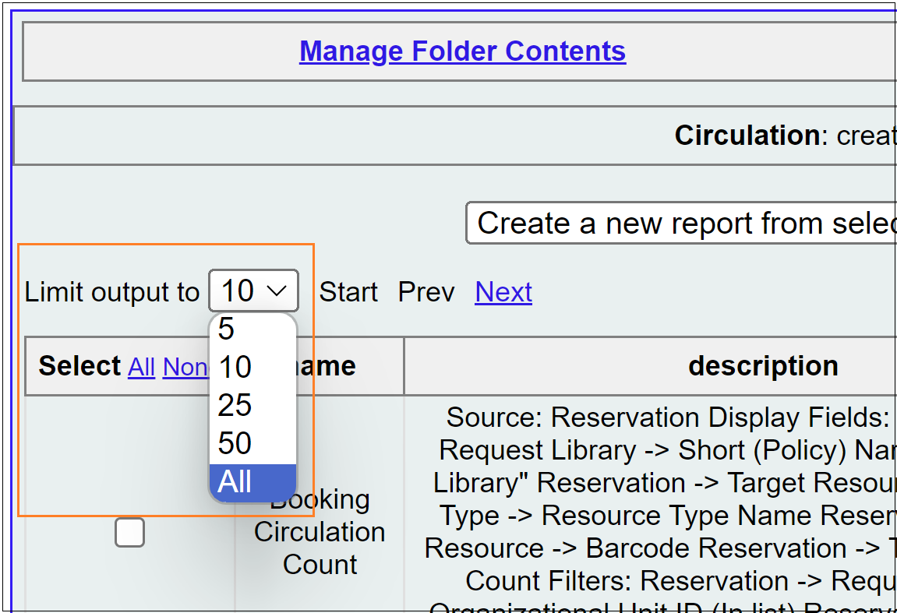
- Reports only pull information out; they do not change any information on the server.
- There may be multiple ways to find the same information.
- Two reports that look similar may not give you the same results depending on how the report templates are built.
- A 'Count' provides a number; a 'List' provides detailed information.
- When you find a report template you like, clone it to your own folder so you can find it again (sort of like saving a bookmark).
- Circulation numbers do not exist in the database prior to September 2006.
- There is a data difference between NULL and blank (blank once had something there, NULL was always empty).
- There is a data difference between no price and price of $0.00.
- If you find a report that gives you too much information, it is generally a better idea to filter down the results in Excel rather than recreating the report with additional filters.
Notable Shared Folders in the Evergreen Reports Module
- csharp > csharp-shared - Report templates created in response to Help Desk Requests
- ddale > Web Client Templates > Helpdesk Request - Report templates created in response to Help Desk Requests
- ddale > Previous Year End Reports - Report templates created to run the PINES annual reports, but can be re-run for different time periods if needed
- elainehardy - Specialized cataloging reports
- PINESacqadmin - Specialized acquisitions reports
- QRADMIN > Simple Reporting Tool - Report templates used by PINES Quick Reports
- smorrison > Help Desk - Report templates created in response to Help Desk Requests
- terran > Help Desk - Report templates created in response to Help Desk Requests

